Logging Middleware

📝Definition
# Source: AI Source: Provided by: [Data Path: Persons Table -> ID Column: 1, Name_En Column: Motasem Essam] -> From: [ChatGPT] on [1/23/2026]
Logging Middleware records information about requests and responses as they pass through your application.
👉 Think of it as a traffic camera: it captures what happens in your app for debugging, monitoring, or auditing purposes.

🔑 Key Responsibilities
# Source: AI Source: Provided by: [Data Path: Persons Table -> ID Column: 1, Name_En Column: Motasem Essam] -> From: [ChatGPT] on [1/23/2026]
- Log incoming requests (URL, method, headers, payload)
- Log outgoing responses (status code, execution time)
- Track errors or exceptions
- Provide audit trails for security and analysis

🔄 How It Works in Flow
# Source: AI Source: Provided by: [Data Path: Persons Table -> ID Column: 1, Name_En Column: Motasem Essam] -> From: [ChatGPT] on [1/23/2026]
Client → Request → Logging Middleware → Controller → Service → Model → Response → Logging Middleware → Client
- Can run before controller → logs request details
- Can run after controller → logs response details

🧱 Examples

1️⃣ Laravel Logging Middleware
# Source: AI Source: Provided by: [Data Path: Persons Table -> ID Column: 1, Name_En Column: Motasem Essam] -> From: [ChatGPT] on [1/23/2026]
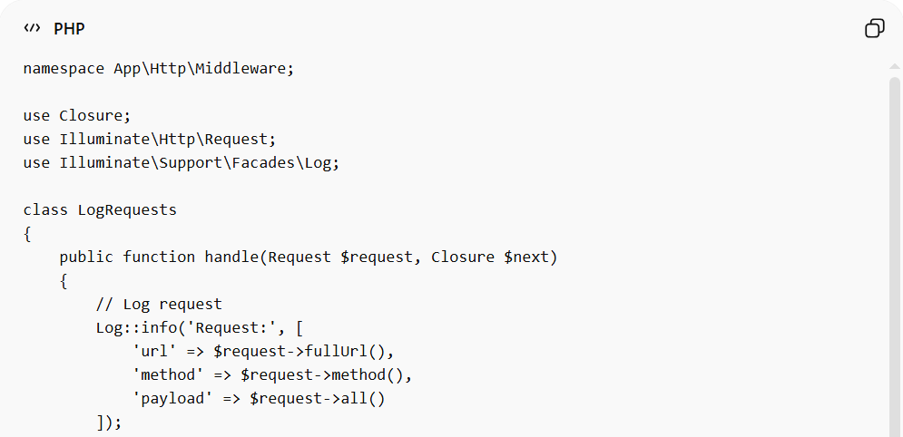
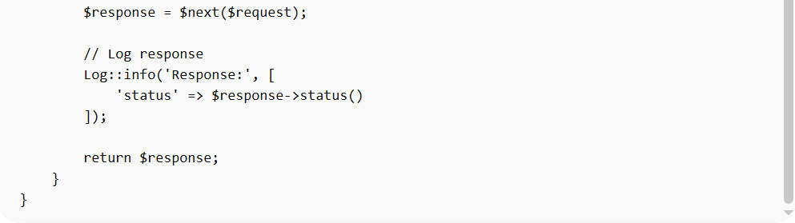
namespace App\Http\Middleware;

use Closure;
use Illuminate\Http\Request;
use Illuminate\Support\Facades\Log;

class LogRequests
{
public function handle(Request $request, Closure $next)
{
// Log request
Log::info('Request:', [
'url' => $request->fullUrl(),
'method' => $request->method(),
'payload' => $request->all()
]);

$response = $next($request);

// Log response
Log::info('Response:', [
'status' => $response->status()
]);

return $response;
}
}

2️⃣ Example Output
# Source: AI Source: Provided by: [Data Path: Persons Table -> ID Column: 1, Name_En Column: Motasem Essam] -> From: [ChatGPT] on [1/23/2026]
[INFO] Request: {"url":"/api/users","method":"POST","payload":{"name":"John"}}
[INFO] Response: {"status":201}

❌ Bad Example (Logging Scattered)
# Source: AI Source: Provided by: [Data Path: Persons Table -> ID Column: 1, Name_En Column: Motasem Essam] -> From: [ChatGPT] on [1/23/2026]
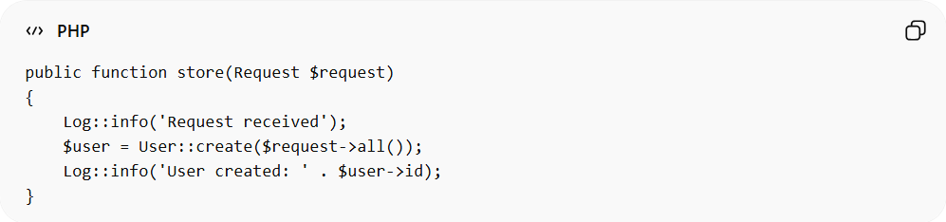
public function store(Request $request)
{
Log::info('Request received');
$user = User::create($request->all());
Log::info('User created: ' . $user->id);
}
Problems:
- Logs are scattered in controllers ❌
- Hard to maintain or standardize ❌
- Violates separation of concerns ❌

✅ Good Example (Middleware Logging)
# Source: AI Source: Provided by: [Data Path: Persons Table -> ID Column: 1, Name_En Column: Motasem Essam] -> From: [ChatGPT] on [1/23/2026]
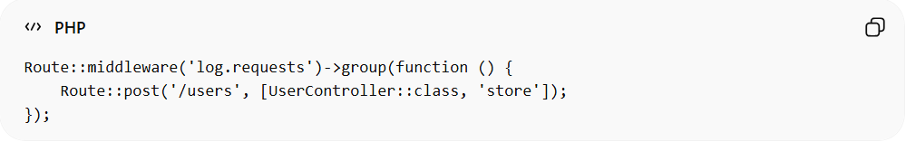
Route::middleware('log.requests')->group(function () {
Route::post('/users', [UserController::class, 'store']);
});
- Centralized logging ✅
- Clean controllers ✅
- Standardized log format ✅

🔄 Relation to Other Middleware Types
# Source: AI Source: Provided by: [Data Path: Persons Table -> ID Column: 1, Name_En Column: Motasem Essam] -> From: [ChatGPT] on [1/23/2026]
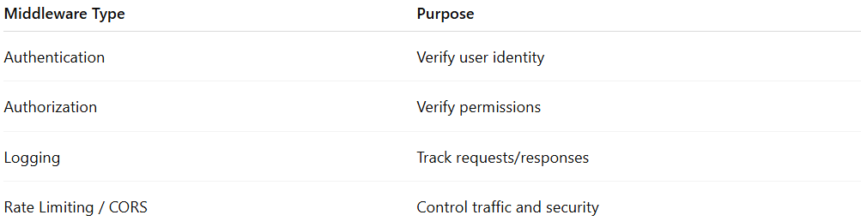
Middleware Type | Purpose
Authentication | Verify user identity
Authorization | Verify permissions
Logging | Track requests/responses
Rate Limiting / CORS | Control traffic and security

⚠️ Common Mistakes
# Source: AI Source: Provided by: [Data Path: Persons Table -> ID Column: 1, Name_En Column: Motasem Essam] -> From: [ChatGPT] on [1/23/2026]
- Logging sensitive data (passwords, tokens) ❌
- Placing logs inside controllers instead of middleware ❌
- Logging too much in production ❌ (use levels or filters)

💡 Key Idea
# Source: AI Source: Provided by: [Data Path: Persons Table -> ID Column: 1, Name_En Column: Motasem Essam] -> From: [ChatGPT] on [1/23/2026]
Logging Middleware centralizes request and response logging, making your system easier to debug, monitor, and audit.

🧾 Summary
# Source: AI Source: Provided by: [Data Path: Persons Table -> ID Column: 1, Name_En Column: Motasem Essam] -> From: [ChatGPT] on [1/23/2026]
- Captures incoming and outgoing traffic
- Centralized and reusable ✅
- Keeps controllers clean
- Provides audit trail and debugging info

